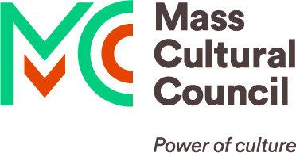
EBT Card to Culture
Photos of Electronic Benefit Transfer (EBT) cards that should be accepted for the Card to Culture discount
Any bearer of a card you accept (EBT, WIC, or ConnectorCare) should be given the discount(s) you offer that population. You cannot ask for a photo ID in addition to the EBT card.

There are three different versions of the Massachusetts Electronic Benefit Transfer (EBT) card that should be accepted in 2023.

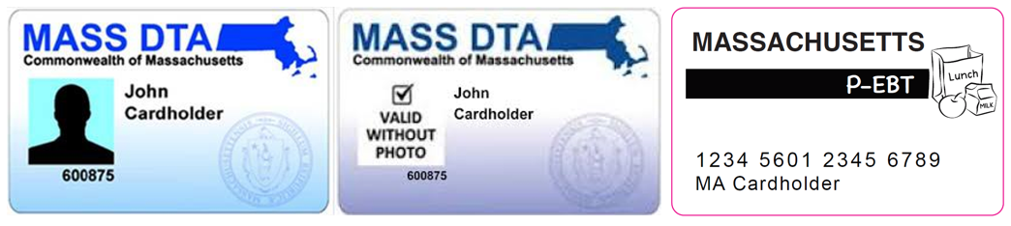
Typical EBT Card STILL VALID without photo Pandemic EBT Card, valid for 2023

Not all Massachusetts EBT cards have photos on them, however EBT cards without photos may still be active and valid for other benefits, so they should be accepted for the discount.

For EBT and WIC programs, there is only one card issued per family, so the name or photo on the card may not be the individual who requests the discount. It could happen that a two-parent family of four receives SNAP benefits and the parent who is bringing their child(ren) to your institution is not the “head of household” so does not have their photo on the card.

If your organization extends the discount to visitors with EBT cards administered by other states, know that each state’s EBT card looks different.

Please note that the EBT card can be verified over phone or online, as all card numbers start with the same six digits (600875). Places that require a code could say “enter the first six digits of your EBT Card Number.” Do not ask for the entire card number, as that must remain confidential per the contract with the card vendor. You could verify the card when the visitor arrives in person, or (best practice) take people at their word when they self-identify as being eligible for this discount.

