ConnectorCare Card to Culture
Photos of ConnectorCare Health Insurance Cards that should be accepted for the Card to Culture discount
Any bearer of a card you accept (EBT, WIC, or ConnectorCare) should be given the discount(s) you offer that population. Do not ask for a photo ID in addition to the ConnectorCare card.
There are five (5) different versions of ConnectorCare cards – one for each of the participating health insurance companies. Look for the label “ConnectorCare,” rather than just the Health Connector logo. Not all health insurance plans administered through the Health Connector system are eligible.
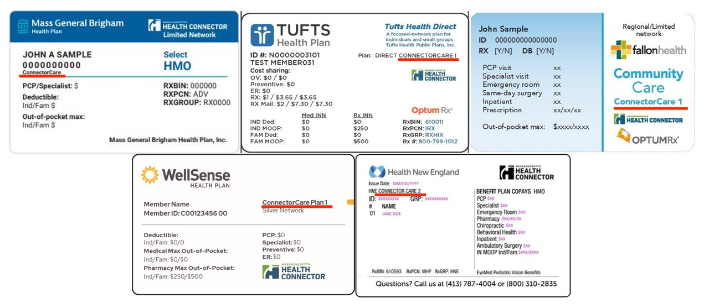
ConnectorCare health insurance cards do not have identification photos on them.

Note that multiple family members (but not all) may have a ConnectorCare card, unlike WIC and EBT cards which are issued one per household.

Unlike with EBT cards, there is no common identifying number or other way to verify ConnectorCare health insurance cards via phone or internet. Instead, organizations may set a discount code (such as “WelcomeCC”) to be entered by ConnectorCare cardholders into an online admissions system. The code would only be advertised on the website for ConnectorCare cardholders, hosted by our partner agency. You could verify the card when the visitor arrives in person, or (best practice) take people at their word when they self-identify as being eligible for this discount.

